ABC’s Inventory Management System

Manage Staff (Search Staff) Test Scripts

Table of Contents

SST001- Search Staff using first name 3

Data Set 1 3

SST002- Search Staff using last name 4

Data Set 1 4

Data Set 2 6

SST003- Search Staff using username 7

Data Set 1 7

SST004- Search Staff using value that does not exist 8

Data Set 1 9

# SST001- Search Staff using first name

|  |  |  |  |  |  |
| --- | --- | --- | --- | --- | --- |
| **Test Name** | | Test search staff using first name (Test SST001) | | | |
| **Use Case Tested** | | Manage Staff | | | |
| **Test Description** | | This test tests if a user can be searched using their first name. | | | |
| **Pre-Conditions** | | Users need be logged in as a Warehouse Staff (Warehouse Staff Access) in the Manage Staff page | | | |
| **Post-Conditions** | | Matching users are displayed | | | |
| **Result (Pass/Fail/Warning/ Incomplete)** | | Pass | | | |
|  | **Test Step** | | **Expected Test Results** | **P** | **F** |
| 1. | Enter user’s first name in the Search Field. | | System waits for the user to click on the ‘Search’ icon | P |  |
| 2. | Click on the ‘Search’ icon. | | System displays the user details of the user(s) that matches with the first name entered. | P |  |

## Data Set 1

|  |  |
| --- | --- |
| **Data Set 1** | |
| **Field** | **Values** |
| **First Name** | Bennie |

**Step 1**

Enter the first name of the staff to be searched

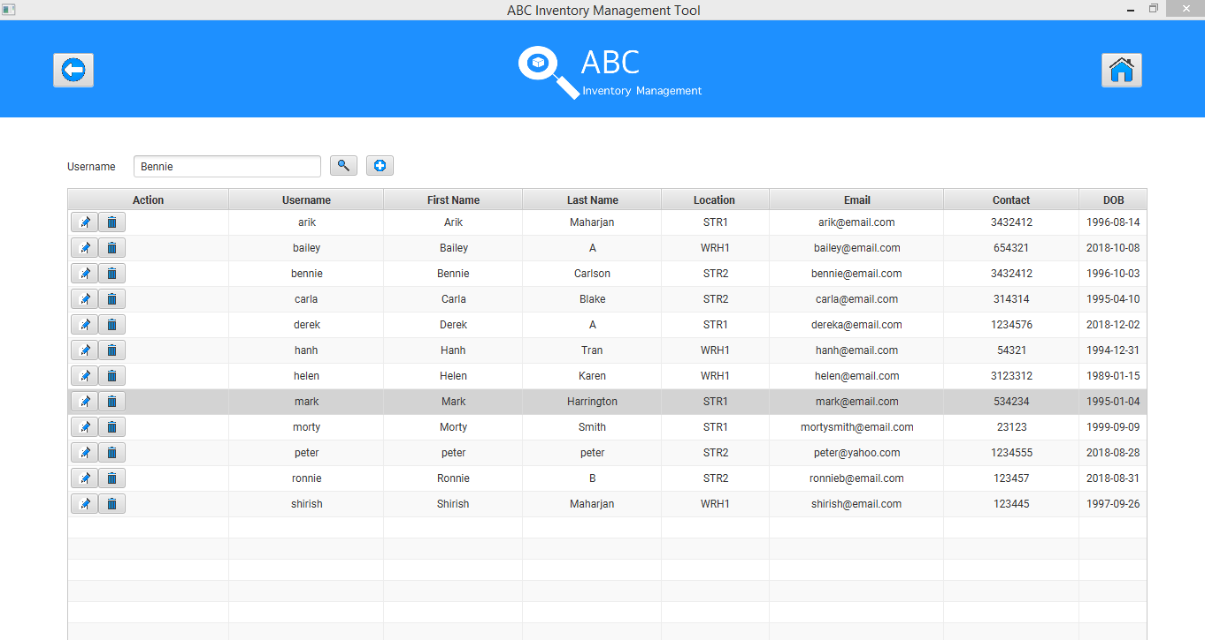

**Step 2**

System displays the staff details matching with the first name entered.

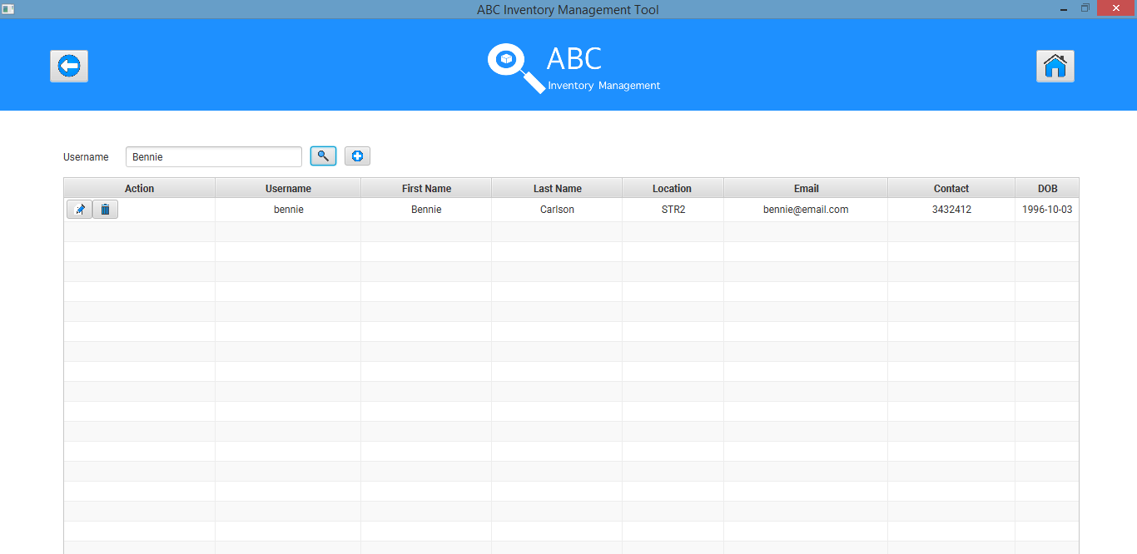

# SST002- Search Staff using last name

|  |  |  |  |  |  |
| --- | --- | --- | --- | --- | --- |
| **Test Name** | | Test search staff using last name (Test SST002) | | | |
| **Use Case Tested** | | Manage Staff | | | |
| **Test Description** | | This test tests if a user can be searched using their last name. | | | |
| **Pre-Conditions** | | Users need be logged in as a Warehouse Staff (Warehouse Staff Access) in the Manage Staff page | | | |
| **Post-Conditions** | | Matching users are displayed | | | |
| **Result (Pass/Fail/Warning/ Incomplete)** | | Pass | | | |
|  | **Test Step** | | **Expected Test Results** | **P** | **F** |
| 1. | Enter user’s last name in the Search Field. | | System waits for the user to click on the ‘Search’ icon | P |  |
| 2. | Click on the ‘Search’ icon. | | System displays the user details of the user(s) that matches with the last name entered. | P |  |

## Data Set 1

|  |  |
| --- | --- |
| **Data Set 1** | |
| **Field** | **Values** |
| **First Name** | Tran |

**Step 1**

Enter the last name of the staff to be searched

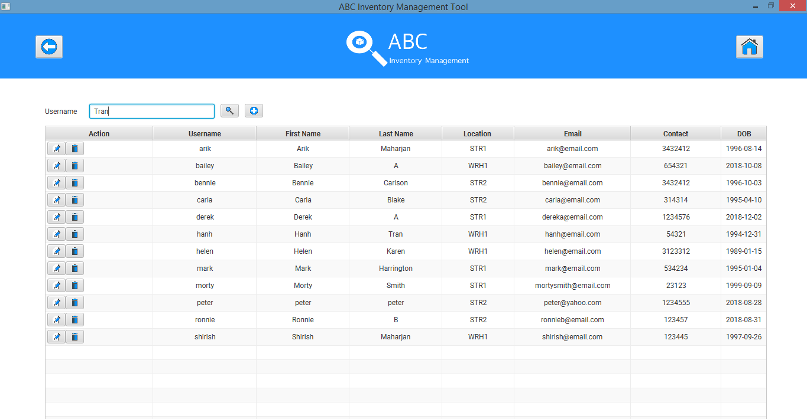

**Step 2**

System displays the staff details matching with the last name entered.

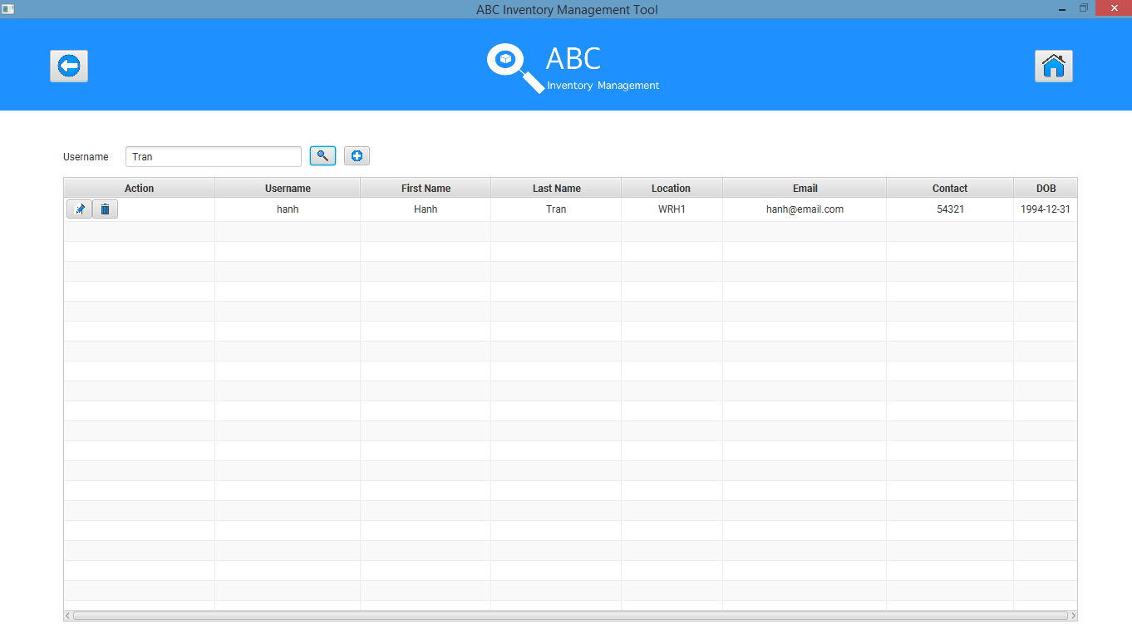

## Data Set 2

|  |  |
| --- | --- |
| **Data Set 2** | |
| **Field** | **Values** |
| **First Name** | Maharjan |

**Step 1**

Enter the last name of the staff to be searched

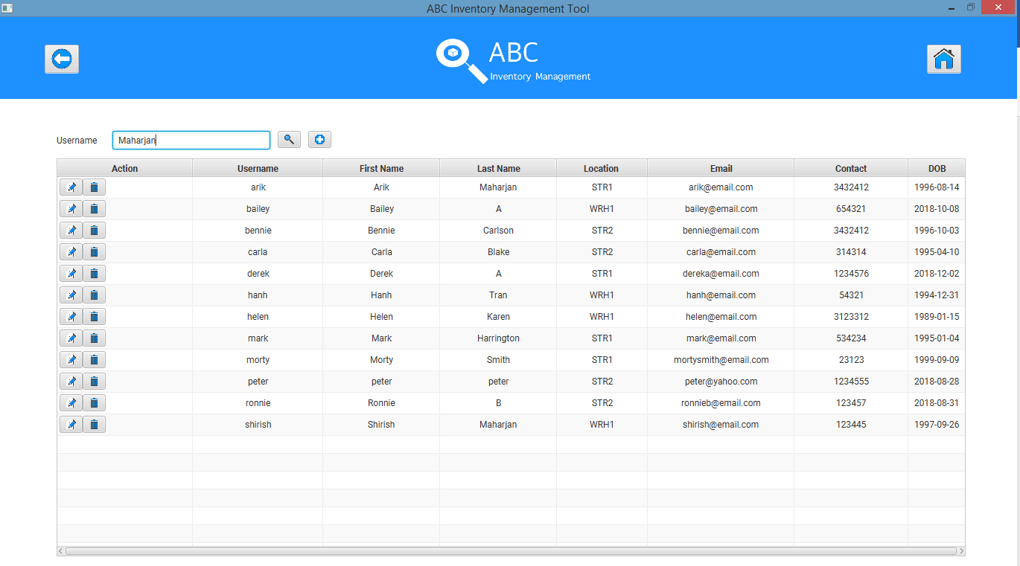

**Step 2**

System displays the staff details matching with the last name entered.

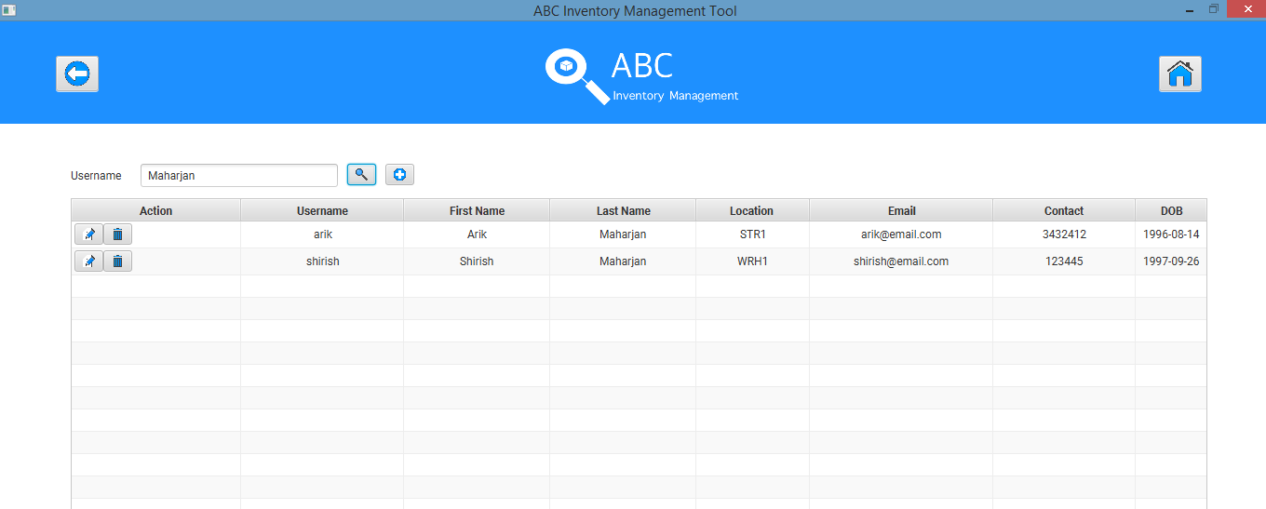

# SST003- Search Staff using username

|  |  |  |  |  |  |
| --- | --- | --- | --- | --- | --- |
| **Test Name** | | Test search staff using username (Test SST003) | | | |
| **Use Case Tested** | | Manage Staff | | | |
| **Test Description** | | This test tests if a user can be searched using their username. | | | |
| **Pre-Conditions** | | Users need be logged in as a Warehouse Staff (Warehouse Staff Access) in the Manage Staff page | | | |
| **Post-Conditions** | | Searched user is displayed. | | | |
| **Result (Pass/Fail/Warning/ Incomplete)** | | Pass | | | |
|  | **Test Step** | | **Expected Test Results** | **P** | **F** |
| 1. | Enter user’s username in the Search Field. | | System waits for the user to click on the ‘Search’ icon | P |  |
| 2. | Click on the ‘Search’ icon. | | System displays the user details of the user that matches with the username entered. | P |  |

## Data Set 1

|  |  |
| --- | --- |
| **Data Set 1** | |
| **Field** | **Values** |
| **First Name** | mark |

**Step 1**

Enter the username of the staff to be searched

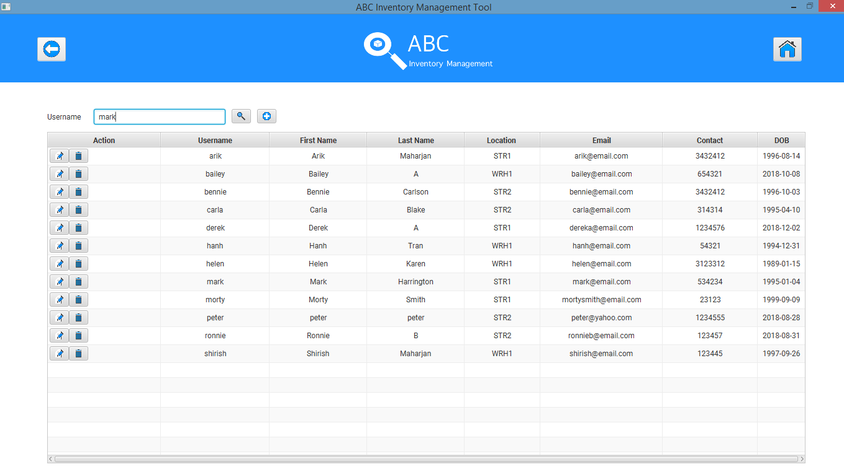

**Step 2**

System displaying the staff details matching with the username searched.

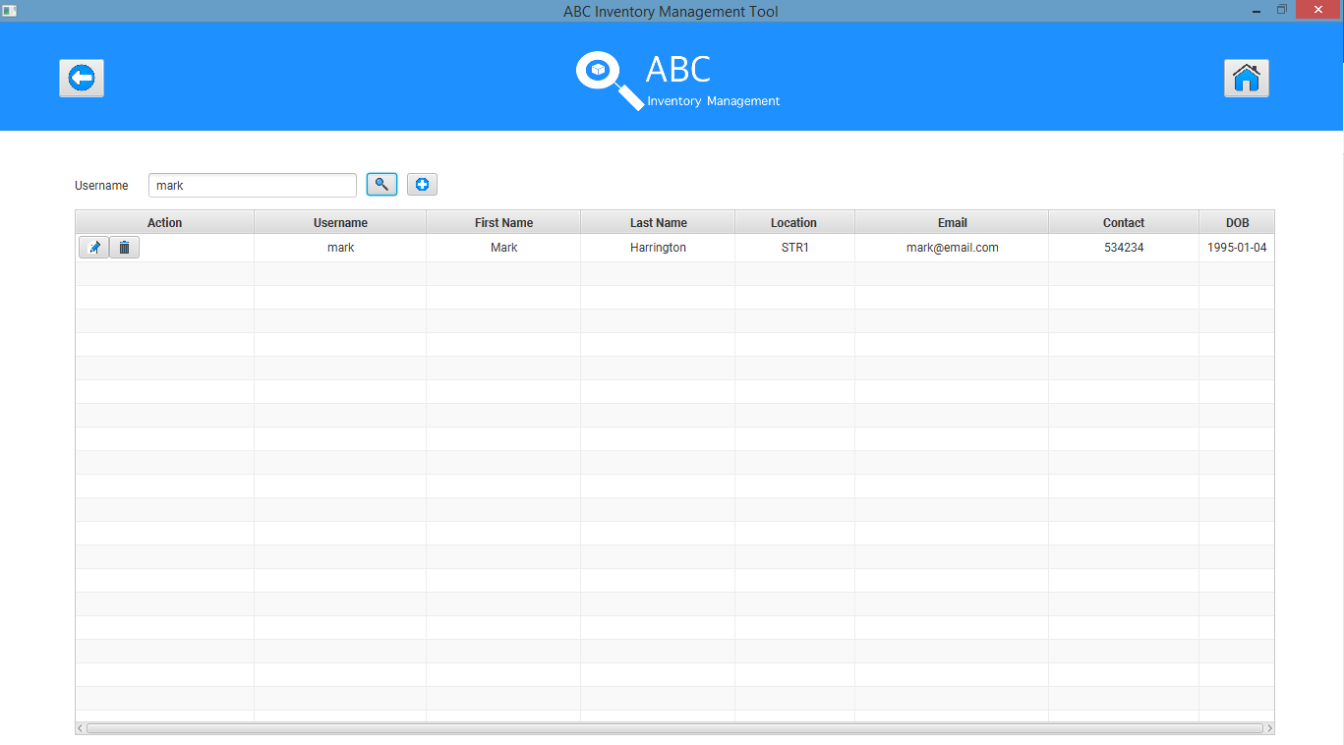

# 

# SST004- Search Staff using value that does not exist

|  |  |  |  |  |  |
| --- | --- | --- | --- | --- | --- |
| **Test Name** | | Test search staff using value that does not exist (Test SST004) | | | |
| **Use Case Tested** | | Manage Staff | | | |
| **Test Description** | | This test tests how the system reacts when a value that does not exist is entered in the Search Field | | | |
| **Pre-Conditions** | | Users need be logged in as a Warehouse Staff (Warehouse Staff Access) in the Manage Staff page | | | |
| **Post-Conditions** | | Appropriate error message is displayed | | | |
| **Result (Pass/Fail/Warning/ Incomplete)** | | Pass | | | |
|  | **Test Step** | | **Expected Test Results** | **P** | **F** |
| 1. | Enter random value that does not exist in the database in the Search Field. | | System waits for the user to click on the ‘Search’ icon | P |  |
| 2. | Click on the ‘Search’ icon. | | Appropriate error message is displayed. | P |  |

## Data Set 1

|  |  |
| --- | --- |
| **Data Set 1** | |
| **Field** | **Values** |
| **First Name** | collin |

**Step 1**

Enter a value that does not exist

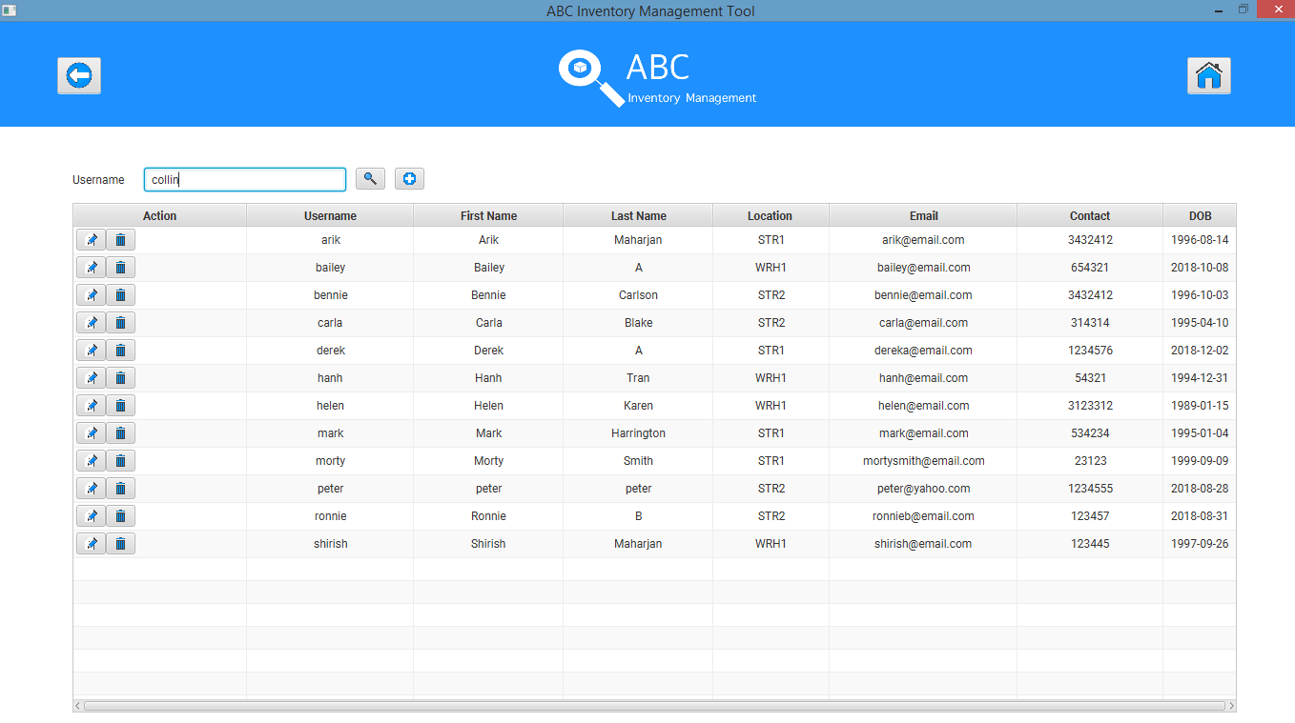

**Step 2**

System displaying an error message

